**Install Wireshark**

**LAB # 04**



**Spring 2025**

Submitted by: **Mohsin Sajjad**

Registration No: **22pwsce2149**

Class Section: **A**

“On my honor, as student of University of Engineering and Technology, I have neither given nor received unauthorized assistance on this academic work.”



Student Signature: ______________

Submitted to:

**Dr. Yasir Saleem Afridi**

Month Day, Year (26 02, 2025)

Department of Computer Systems Engineering

University of Engineering and Technology, Peshawar

**CSE 303L: Data Communication and Computer Networks**

|  |  |  |  |  |
| --- | --- | --- | --- | --- |
| **Demonstration of Concepts** | **Poor (Does not meet expectation (1))**  The student failed to demonstrate a clear understanding of the assignment concepts | **Fair (Meet Expectation (2-3))**  The student demonstrated a clear understanding of some of the assignment concepts | **Good (Exceeds Expectation (4-5)**  The student demonstrated a clear understanding of the assignment concepts | **Score**  **30%** |
| **Accuracy** | The student mis-configured enough network settings that the lab computer couldn't function properly on the network | The student configured enough network settings that the lab computer partially functioned on the network | The student configured the network settings that the lab computer fully functioned on the network | **30%** |
| **Following Directions** | The student clearly failed to follow the verbal and written instructions to successfully complete the lab | The student failed to follow the some of the verbal and written instructions to successfully complete all requirements of the lab | The student followed the verbal and written instructions to successfully complete requirements of the lab | **20%** |
| **Time Utilization** | The student failed to complete even part of the lab in the allotted amount of time | The student failed to complete the entire lab in the allotted amount of time | The student completed the lab in its entirety in the al | **20%** |

**Credit Hours: 1**

Objectives

Download and Install Wireshark

# Background / Scenario

Wireshark is a software protocol analyzer, or "packet sniffer" application, used for network troubleshooting, analysis, software and protocol development, and education. As data streams travel back and forth over the network, the sniffer "captures" each protocol data unit (PDU) and can decode and analyze its content according to the appropriate RFC, or other specifications.

Wireshark is a useful tool for anyone working with networks and can be used with most labs in the CCNA courses for data analysis and troubleshooting. This lab provides instructions for downloading and installing Wireshark.

# Required Resources

* 1 PC (Windows with internet access)

# Instructions

Wireshark has become the industry standard packet-sniffer program used by network engineers. This open-source software is available for many different operating systems, including Windows, Mac, and Linux. In this lab, you will download and install the Wireshark software program on your PC.

Note: Before downloading Wireshark, check with your instructor about the software download policy of your academy.

## Download Wireshark.

* + 1. Wireshark can be downloaded from [www.wireshark.org](http://www.wireshark.org).
    2. Choose the software version you need based on your PC’s architecture and operating system. For instance, if you have a 64-bit PC running Windows, choose Windows Installer (64-bit).

After making a selection, the download should start. The location of the downloaded file depends on the browser and operating system that you use. For Windows users, the default location is the Downloads folder.

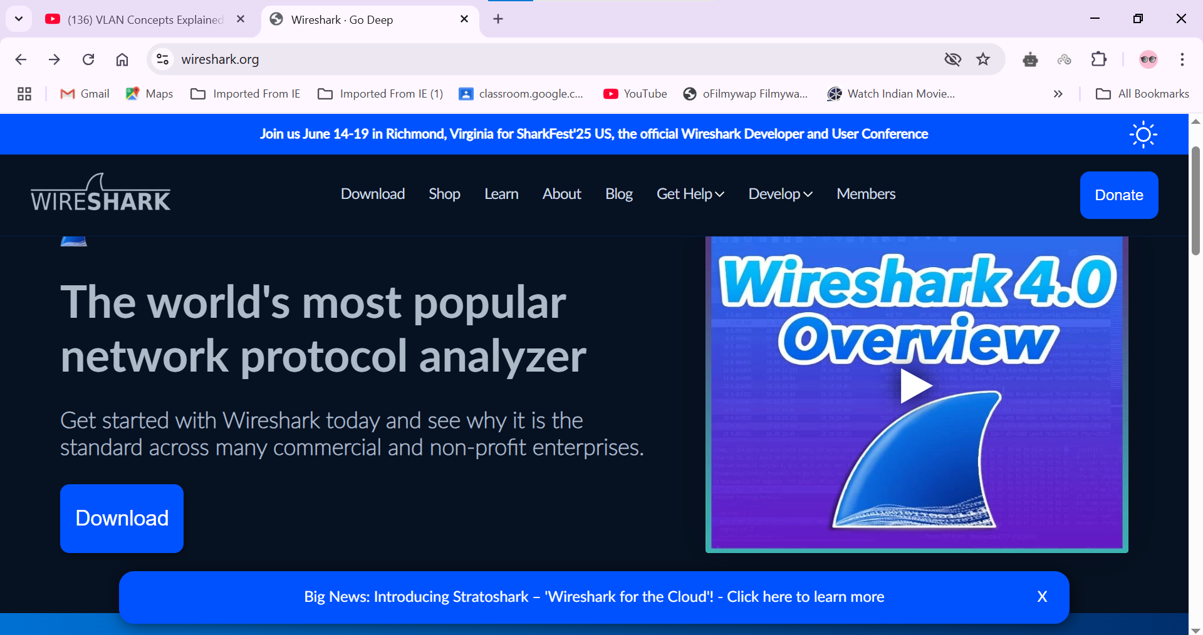

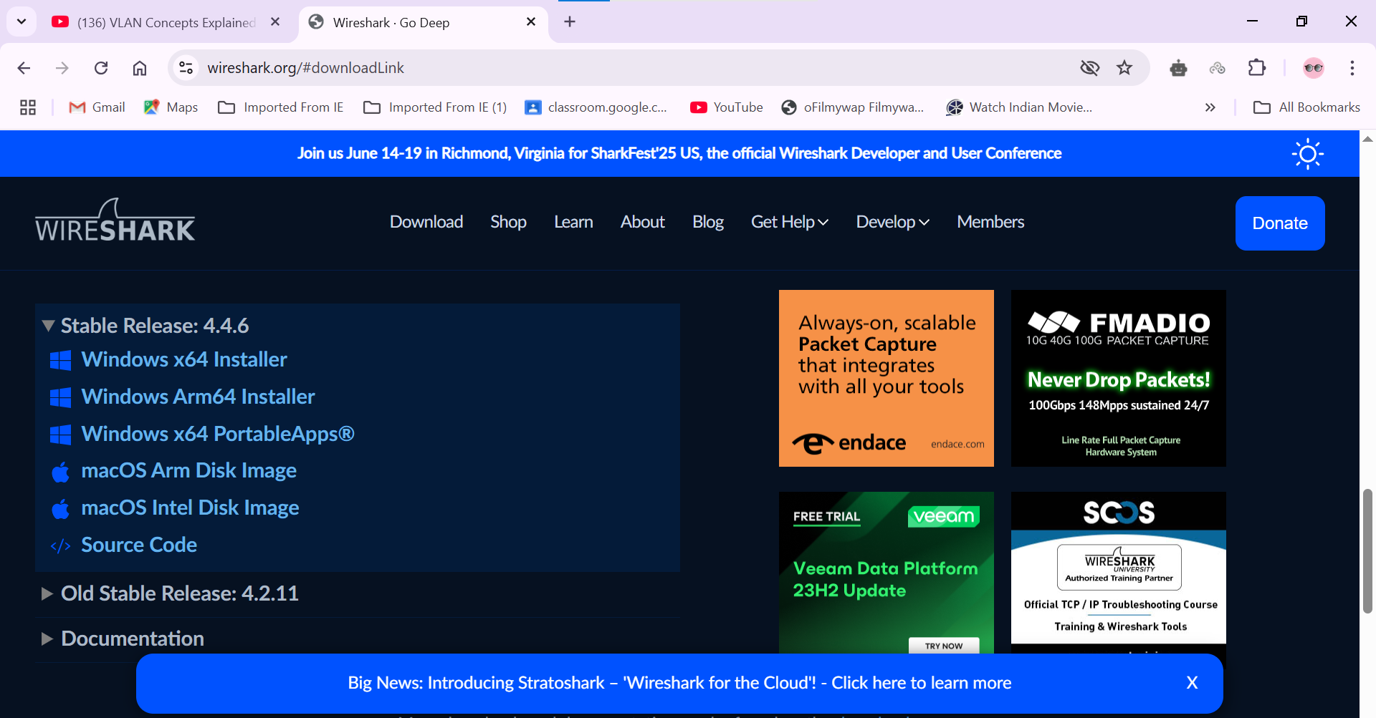

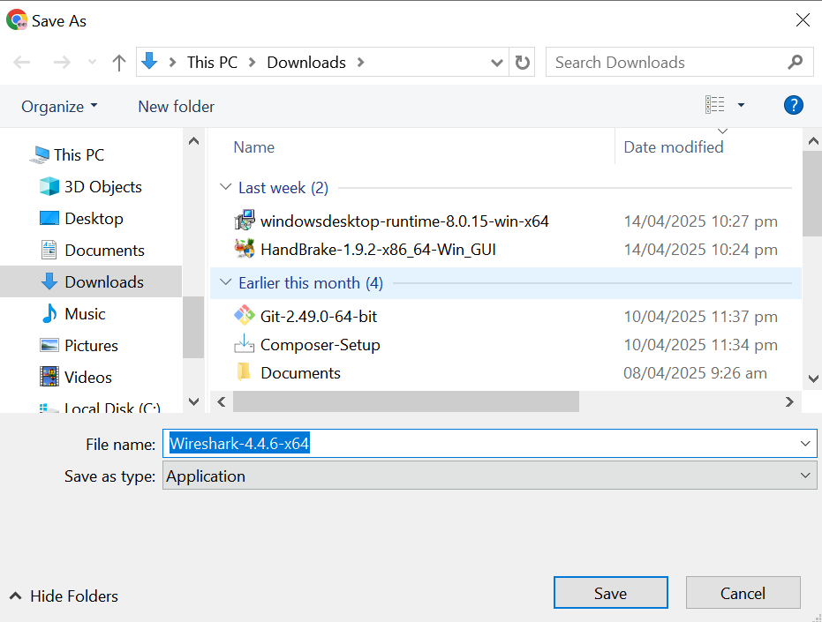

## Install Wireshark.

* + 1. The downloaded file is named Wireshark-win64-x.x.x.exe, where x represents the version number if you downloaded the 64bit version. Double-click the file to start the installation process.

Respond to any security messages that may display on your screen. If you already have a copy of Wireshark on your PC, you will be prompted to uninstall the old version before installing the new version. It is recommended that you remove the old version of Wireshark prior to installing another version. Click Yes to uninstall the previous version of Wireshark.

* + 1. If this is your first time to install Wireshark, or after you have completed the uninstall process, you will navigate to the Wireshark Setup wizard. Click Next.
    2. Continue advancing through the installation process. Click I Agree when the License Agreement window displays.
    3. Keep the default settings on the Choose Components window and click Next.
    4. Choose your desired shortcut options and click Next.
    5. You can change the installation location of Wireshark, but unless you have limited disk space, it is recommended that you keep the default location. Click Next to continue.
    6. To capture live network data, Npcap must be installed on your PC. If Npcap is already installed on your PC, the Install check box will be unchecked. If your installed version of Npcap is older than the version that comes with Wireshark, it is recommended that you allow the newer version to be installed by clicking the Install Npcap x.x.x (version number) check box. Click Next to continue.
    7. Do NOT install USBPcap for normal traffic capture. Do NOT select the checkbox to install USBPcap. USBPcap is experimental, and it could cause USB problems on your PC. Click Install to continue.
    8. **Wireshark starts installing its files and displays with the status of the installation.**
    9. **In a separate window, accept the license agreement in the Npcap Setup Wizard if installing Npcap. Click I Agree to continue. Click Install to install Npcap. Click Next to finish the Npcap installation and click Finish to exit the Npcap installation.**
    10. **Click Next when the Wireshark installation is complete.**
    11. 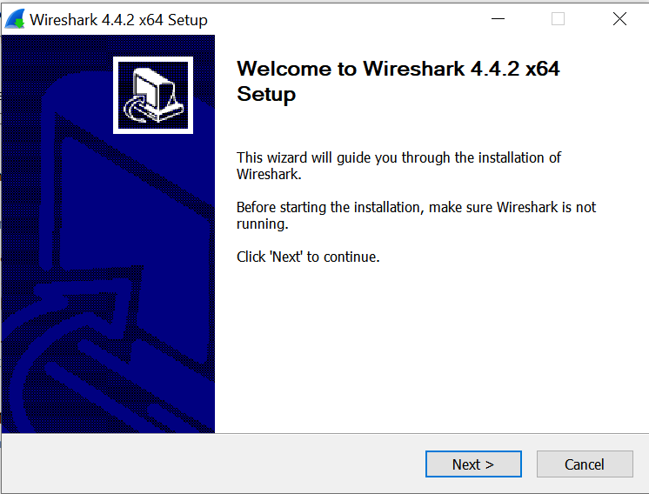**Click Finish to complete the Wireshark install process. Reboot the computer if necessary.**

